**Object Oriented Systems**

**Case Study**

**Hospital Management System**

Submitted By:

Mohamed Reda 000819497

Gabriel Diaconu 000799618

Adeel Masih 000892225

Appendix

1. Cover Page
2. Introduction
3. Functional Requirements
4. Use Case Diagrams
5. Use Case Descriptions
6. Activity Diagrams
7. Sequence Diagrams
8. State Diagrams
9. System User Interface

**Introduction**

Our team is tasked with assessing and building a strong system for a hospital with five doctors and a varied spectrum of healthcare specialists in the always changing field of healthcare administration. The goal of this system is to handle patient records more efficiently. Records of insurance carriers are linked to each patient record, which are organized under households. An all-encompassing solution is required due to the intricate interactions between medical staff participation in patient visits and thorough procedural documentation. We also pay close attention to the detailed documentation of hospital visits, insurance company and patient bills, and reporting features. The business manager and hospital receptionist are essential to the creation of invoices, data entry, and upkeep. Throughout this case study, our team will propose a thorough solution, employing UML diagramming techniques and designing user interfaces, culminating in a comprehensive document ready for real-world implementation in healthcare administration.

**Functional Requirements**

**List ten functional requirements in the proposed system**

a. Patient recording system that lists information about the patient.

b. Head of household record that lists information about the household.

c. Insurance carrier record that contains information about the insurance company.

d. A system that tracks hospital staff interactions with patients.

e. A record system that tracks patient visits to the hospital.

f. A system that records hospital procedures.

g. Invoice tracking system that tracks invoices to insurance companies

h. Invoice tracking system that tracks invoices to patients

i. A system that prints invoices on a set interval.

j. A system that reports lists of procedures performed on a set interval.

**Identify ten use cases from the system using the user goal technique:**

|  |  |
| --- | --- |
| Users: | User Goals: |
| Hospital Staff | Entering information about procedures performed |
| Patients | Access and pay invoices |
| Receptionist | Manage Patient Records  Manage head of household information  Track hospital visits  Generate report of procedures |
| Business Manager | Manage patient records.  Manage staff records.  Verify accuracy of invoices  Schedule and print overdue invoices |

**Identify six use cases from the system using the event decomposition technique.**

| External Events: | Temporal Events: | State Events: |
| --- | --- | --- |
| Enter patient record | Print Patient Invoices monthly | Update invoice payment status |
| Enter hospital visit record | Print Insurance invoices weekly | Overdue invoice identification |

**Write a user story showing the business manager generating a monthly invoice for a patient or household.**

As a business manager, I want to generate accurate monthly invoices for patients, so invoices are paid promptly and accurately.

Acceptance Criteria:

1. Patient details should automatically populate the invoice.

2. Automatically organize invoices by patient name and date.

3. Invoices should include bills and payments received.

4. Patient and procedure details should automatically be cross referenced and verified upon generation.

5. System should include the ability to directly email invoices to patients.

2. **Create use case diagrams showing a complete and comprehensive view of the entire**

**system**

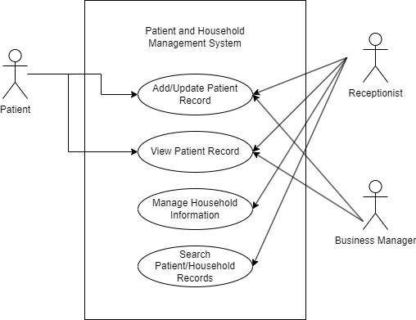

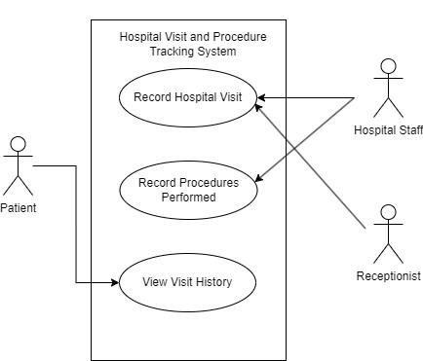

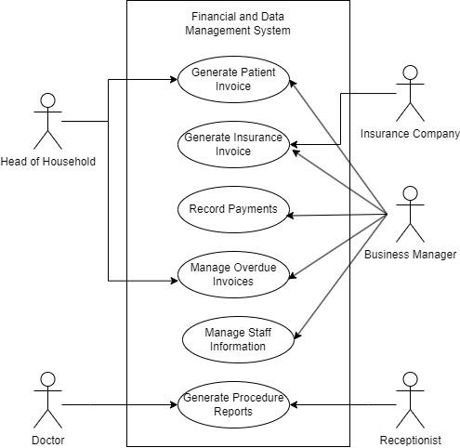

**Two Comprehensive Use Case Descriptions**

**Enter Patient Information Use Case Description**

|  |  |  |
| --- | --- | --- |
| Use Case name: | Enter patient information | |
| Scenario: | Enter patient information into the system. | |
| Triggering event: | New patient wants to give personal information in order to see a doctor. The receptionist selects the “Enter patient information” option. | |
| Brief description: | Receptionist enters patient information in the system and then confirms if this information is accurate with the patient. | |
| Actors: | Receptionist, Patient | |
| Related use cases: | Might be invoked when a new patient comes into a hospital and hasn’t been there before.  Might be invoked when an existing patient comes into a hospital and needs to update their information. | |
| Stakeholders: | Healthcare Providers, Patient Family, Insurance Company, Hospital management, Regulatory Authorities | |
| Preconditions: | The receptionist has logged into the system  Patient subsystem must be available.  Household subsystem must be available.  Visits subsystem must be available. | |
| Postconditions: | Patient name must be entered and saved.  Patient birthdate must be entered and saved.  Patient gender must be entered and saved.  Patient 1st visit must be entered and saved.  Patient last visit must be entered and saved. | |
| Flow of activities | Actor | System |
| 1. Patient indicated desire to visit a doctor for their ailments  2. Receptionist enters patients information into the system | 1.1 System creates a new patient/finds existing patient  1.2 System prompts for patient name  1.3 System saves patient name  1.4 System prompts for patient birthdate  1.5 System saves patient birthdate  1.6 System prompts for patient gender  1.7 System saves patient gender  1.8 System prompts for patients 1st visit  1.9 System saves patients 1st visit  1.10 System prompts for patient last visit  1.11 System saves patients last visit |
| Exception conditions: | Patient birthdate is not valid  Patient gender is not valid  Patient 1st visit is not valid  If data validation fails, the system provides error messages for correction | |

**Enter Visit information Use Case Description**

|  |  |  |
| --- | --- | --- |
| Use Case name: | Enter visit information | |
| Scenario: | Enter patient visit information into the system | |
| Triggering event: | Patient visits a hospital | |
| Brief description: | A receptionist enters visit information for a patient that wants to visit a doctor | |
| Actors: | Receptionist, Patient | |
| Related use cases: | Might be invoked when a new patient comes into a hospital and hasn’t been there before.  Might be invoked when an existing patient comes into a hospital and needs to update their information. | |
| Stakeholders: | Healthcare Providers, Patient Family, Insurance Company, Hospital management, Regulatory Authorities | |
| Preconditions: | The receptionist has logged into the system  Patient subsystem must be available.  Household subsystem must be available.  Visits subsystem must be available. | |
| Postconditions: | Visit date must be entered and saved  Staff seen must be entered and saved  Insurance company must be entered and saved  Insurance co-pay amount must be entered and saved  Code must be entered and saved  Amount must be entered and saved | |
| Flow of activities | Actor | System |
| 1. Patient indicated desire to visit a doctor for their ailments  2. Receptionist enters visit information into the system | 1.1 System creates a new patient/finds existing patient  1.2 System prompts for visit date  1.3 System saves visit date  1.4 System prompts for staff seen  1.5 System saves staff seen  1.6 System prompts for insurance company  1.7 System saves insurance company  1.8 System prompts for insurance co-pay amount  1.9 System saves patients insurance co-pay amount  1.10 System prompts for code  1.11 System saves code  1.12 System prompts for amount  1.13 System saves amount |
| Exception conditions: | Patient visit date is not valid  Patient insurance is not valid  Patient visit code is not valid  Patient amount is not valid  If data validation fails, the system provides error messages for correction | |

**Two Activity Diagrams**

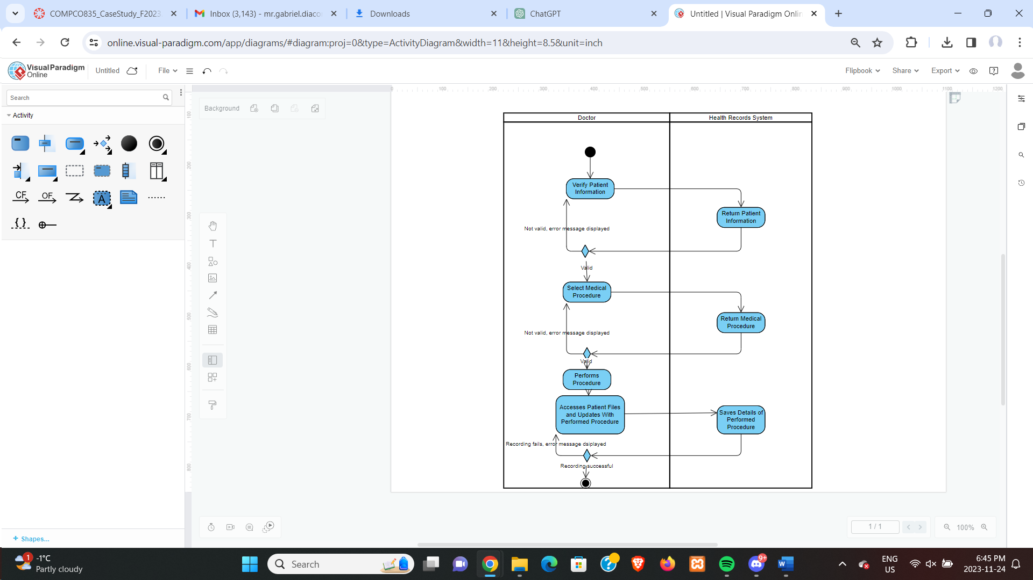

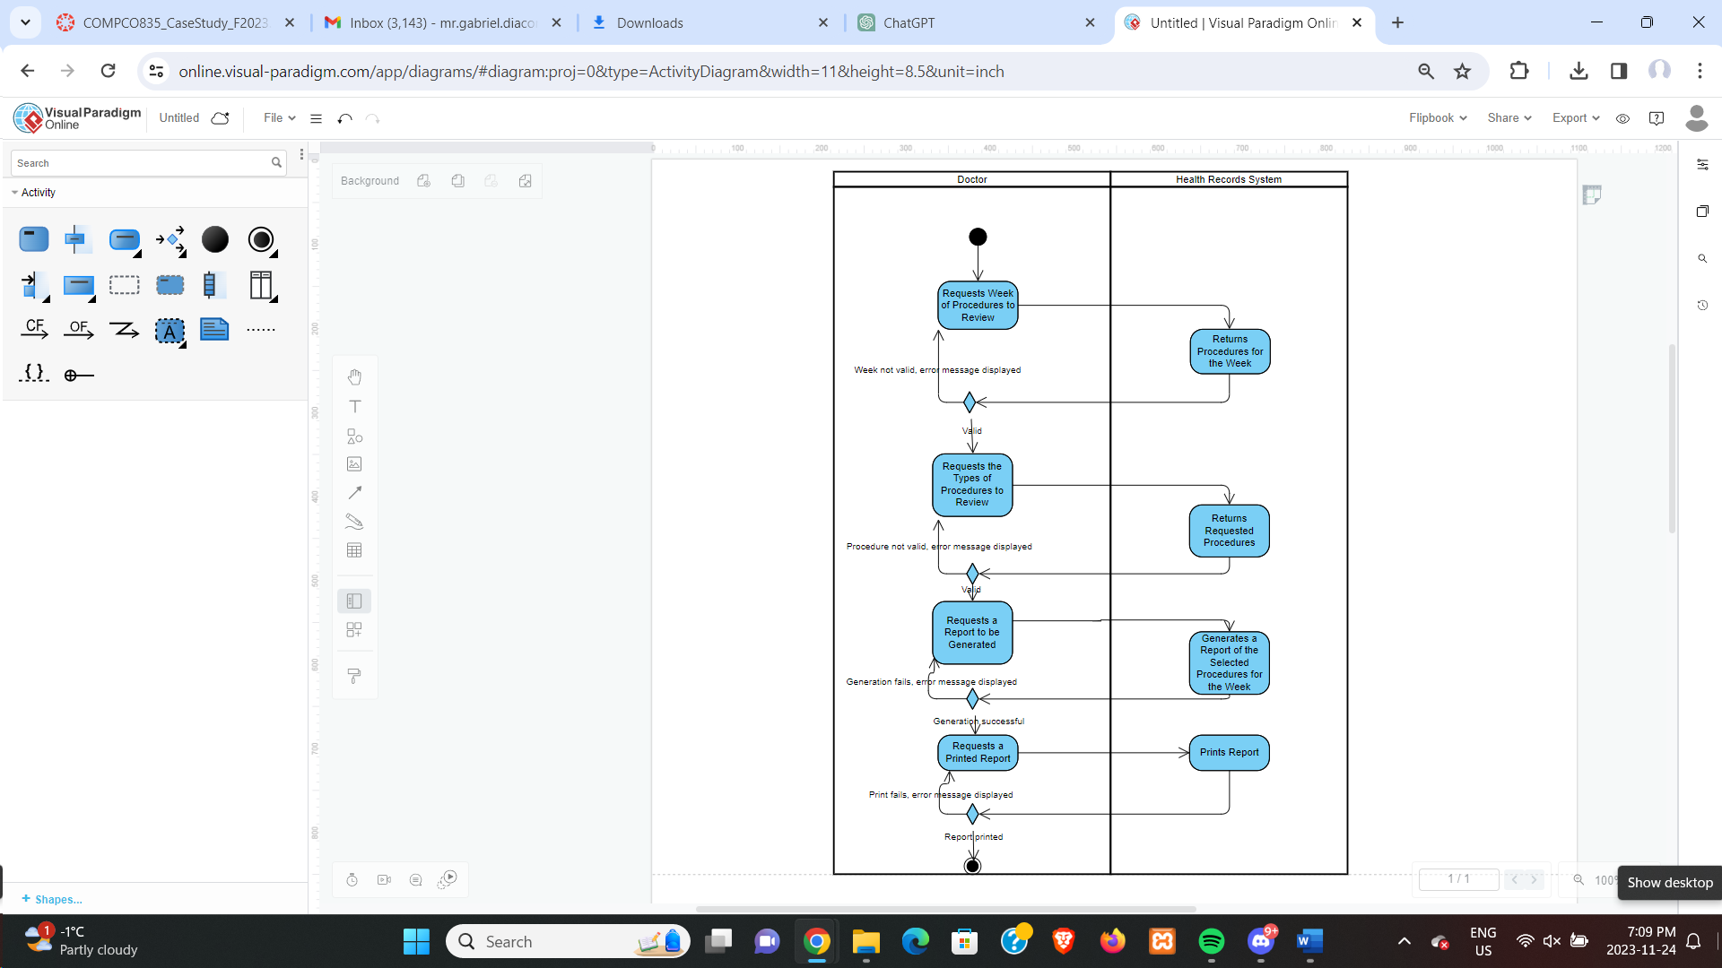**Sequence Diagrams**

**Sequence Diagram Based on Enter Patient Information Use Case Description**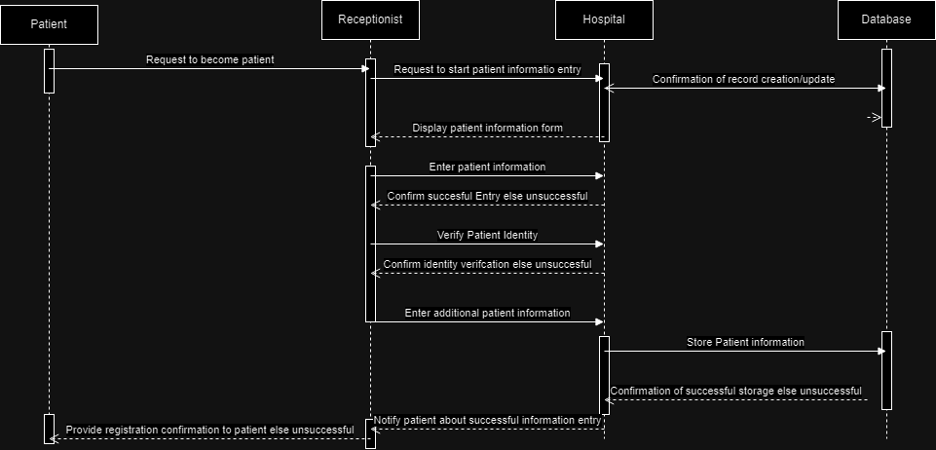

**Sequence Diagram based on Inputting Visit Information Use Case Description**

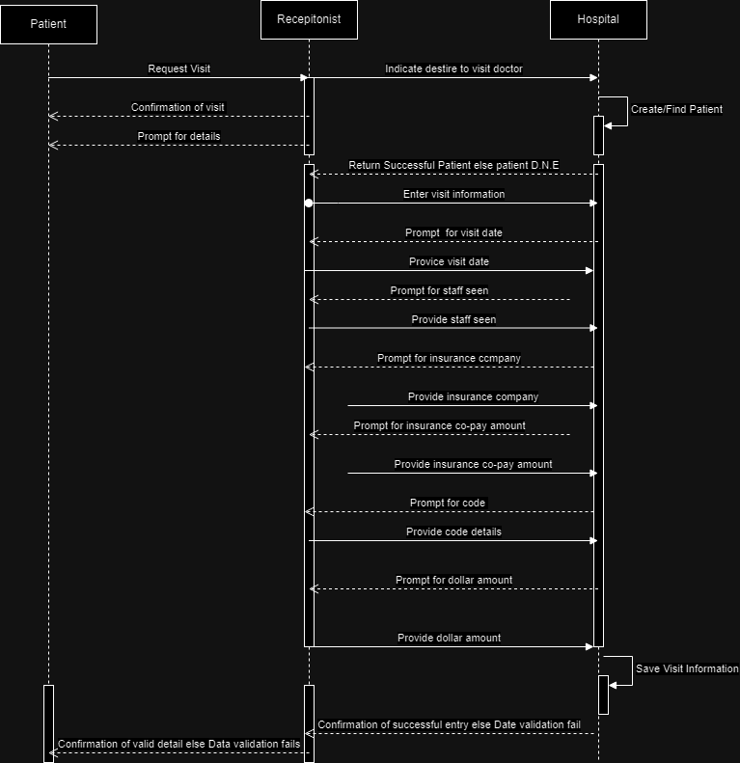

**State Diagram**

**State Diagram based on Enter Patient Information Use Case Description**

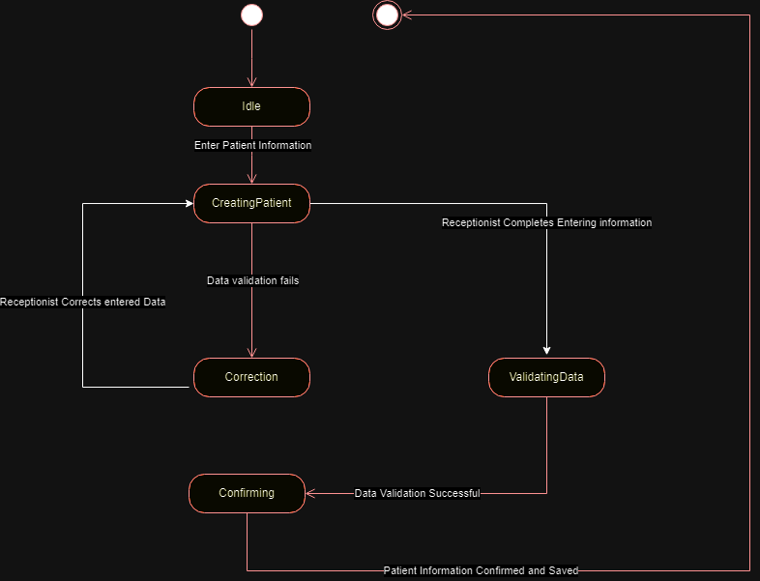

**State Diagram based on Inputting Visit Information Use Case Description**

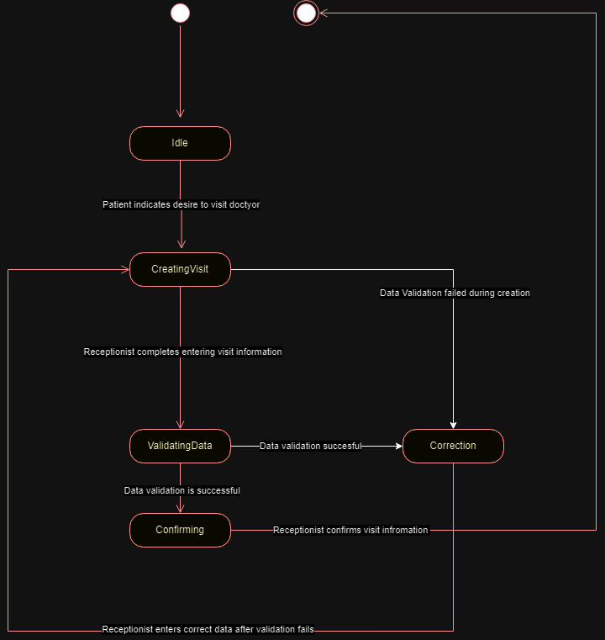

**User Interface For System**

Doctor’s view:

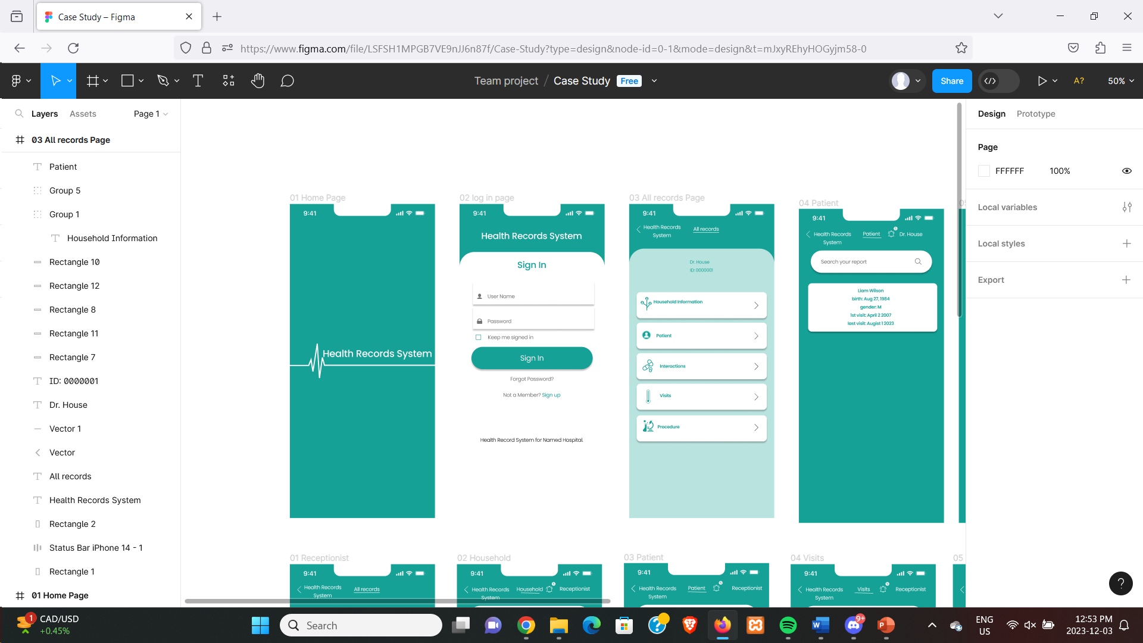

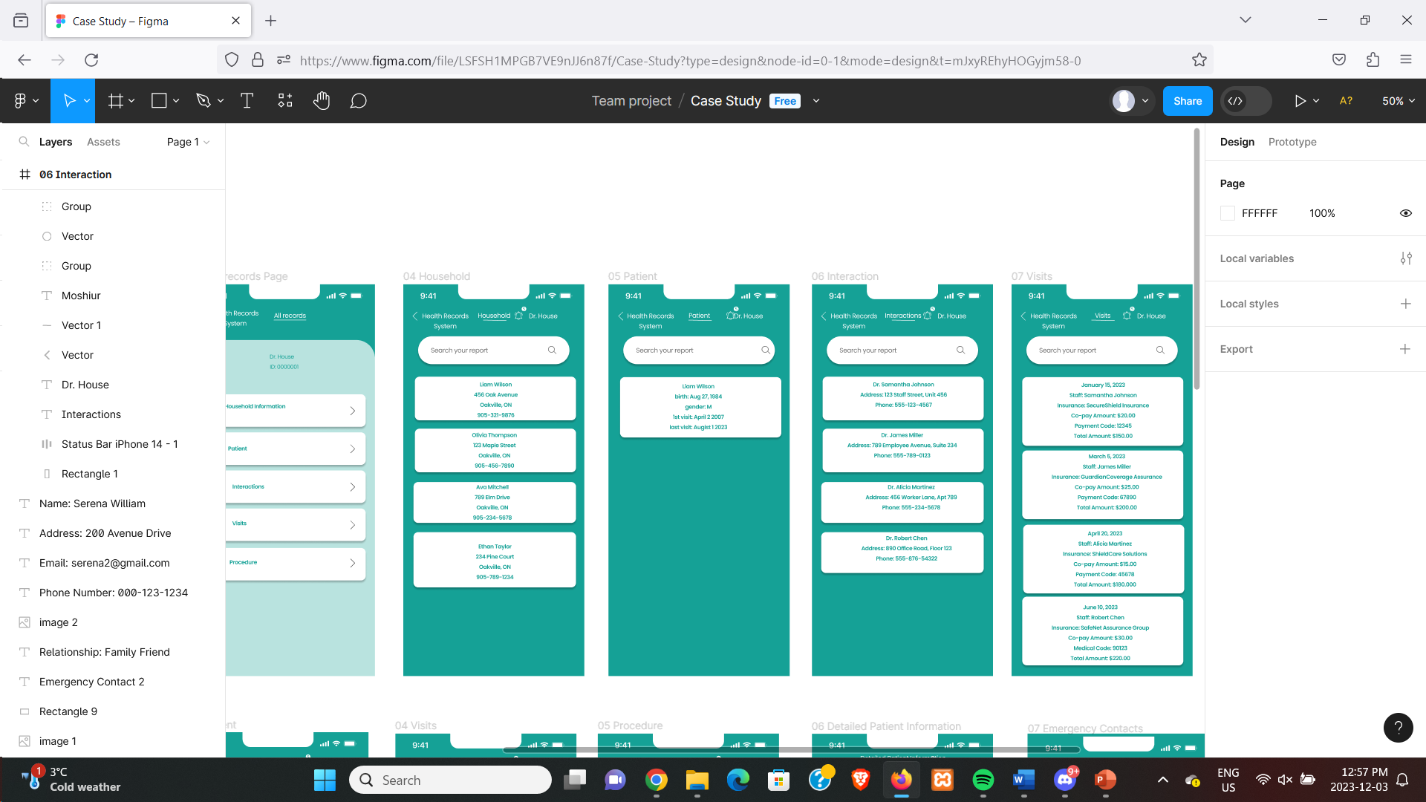

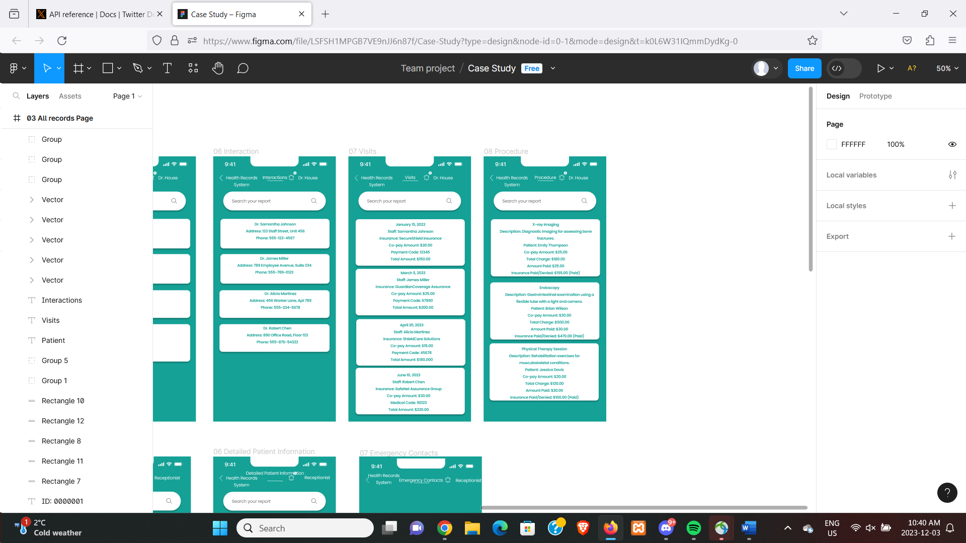

Receptionist view:

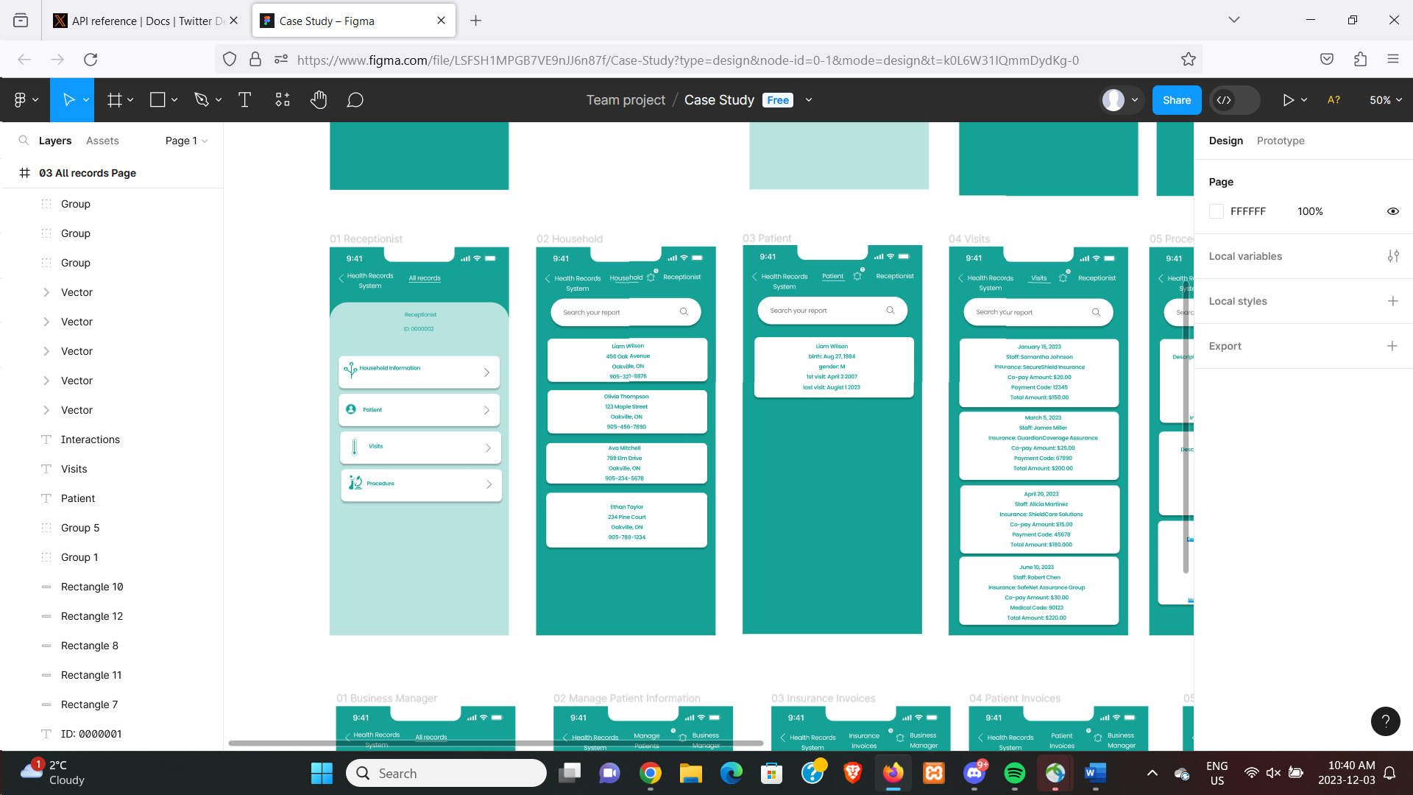

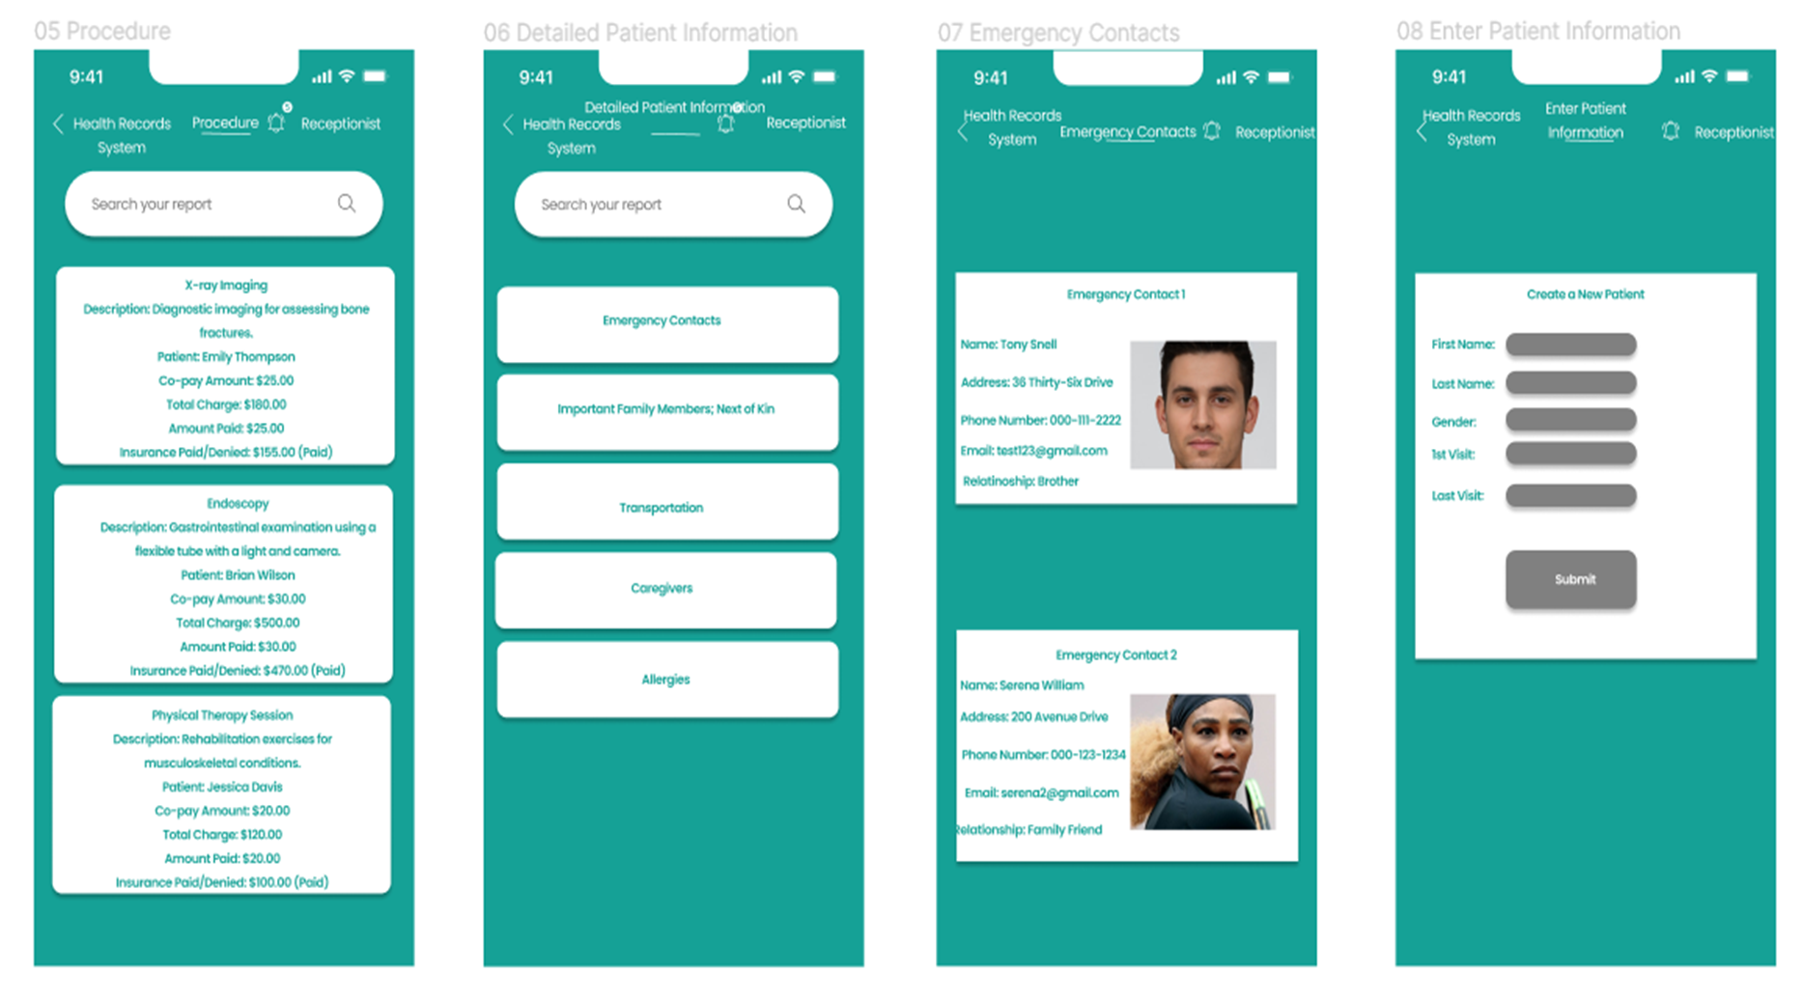

Business managers view:

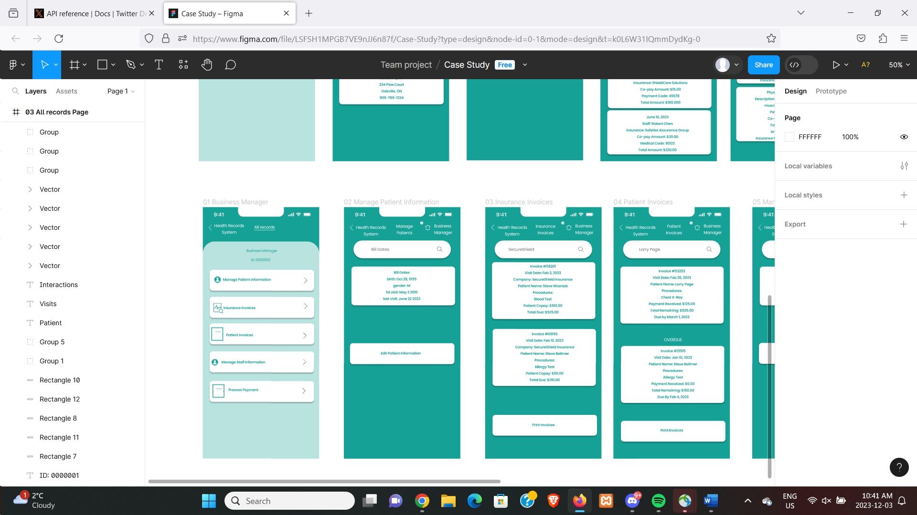

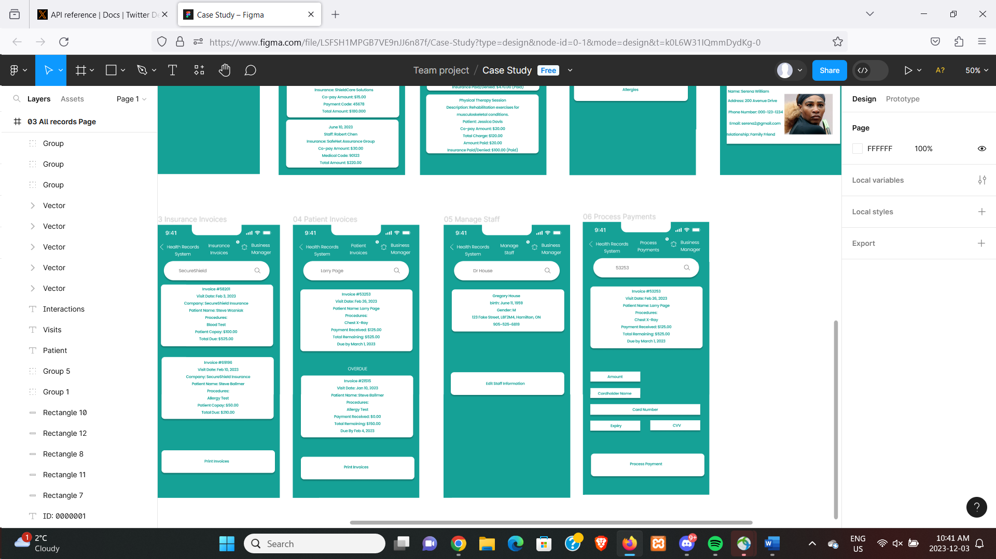

**Conclusion**

In conclusion, an integrated and user-friendly solution for healthcare management is desperately needed, as demonstrated by our analysis and design work for the hospital's patient administration system. The suggested system is in line with the complexities of patient data, staff interaction, and financial transactions. After creating UML diagrams and interface designs we have gathered enough information to make this decision. Together with a well-organized billing system, the hospital's emphasis on accessibility, efficiency, and accuracy in keeping patient and procedure information positions it to provide improved healthcare services. By taking an all-encompassing approach, we hope to empower hospital employees, from business managers and physicians to receptionists, and promote a smooth and effective workflow. As we proceed with managing the project's execution, we are resolute in our commitment to providing a solution that not only meets the specific needs of this hospital but also sets a standard for excellence in healthcare administration systems.

References

Satzinger, J. W., Jackson, R. B., & Burd, S. D. (2015). *Systems analysis and design in a changing world*. Cengage Learning.